**一、Part**

**1.1 PHYTASE(ycD)：BBa_K3408001**

We selected the neutral phytase gene phy(ycD) from <i>*Bacillus sp.</i>* to obtain a large amount of phosphate as phytase could hydrolyze phytic acid or phytate to produce phosphate which could combine with lead ions and Cl<sup>-</sup>(or F<sup>-</sup>,OH<sup>-</sup>) to form insoluble compound pyromorphite (Pb<sub>5</sub> (PO<sub>4</sub>) <sub>3</sub>Cl (F, OH)). Pyromorphite is exceptionally stable, so we can achieve the purpose of precipitating lead and purifying soil.

**1.2 TOEHOLD-mazF：BBa_K3408010**

Toehold switch system consists of switch RNA and trigger RNA. We employed mazF as our suicide protein, which could cleave a single strand of mRNA at a specific sequence site and cause cell death. We skillfully integrated the two elements as our kill switch by adding the switch part to the upstream of the mazF gene. The entire kill switch is regulated by the promoter P<sub>CⅠ</sub>. A special hairpin structure was also added at the 5' end of trigger RNA to increase its stability. Therefore, we can regulate the expression of CⅠ repressor protein and trigger RNA to specifically activate the kill switch of engineered bacteria.

1. **Device**

**2.1P**<sub>nar</sub> **-GFP**

The intestine of earthworms is an anaerobic environment, so we chose and tested the promoter P<sub>nar</sub> that can be activated under an oxygen-free condition. We added the gfp gene at the downstream of promoter P<sub>nar</sub> so that we can determine fluorescent intensity to characterize whether our promoter P<sub>nar</sub> works well.

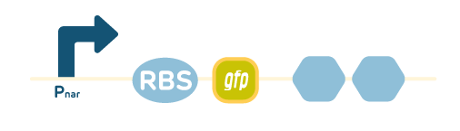

**Fig.1. Device** **P<sub>nar</sub>-GFP**

2.1.1 Strains and vectors

Strain: <i>Bacillus subtilis</i> WB800N

Plasmid: pWB980-DB

2.1.2 Experimental methods

2.1.2.1 Construction of the expression vector

The pWB980-DB is digested with enzyme EcoRI and PstI. The target fragment of the promoter, RBS, gene of green fluorescent protein (GFP) and terminator of this device is synthesized by the biotechnology company according to the known sequence. Add EcoRI and PstI restriction sites to both ends of the target fragment respectively. Connect the target fragment to the plasmid vector fragment to construct the recombinant expression vector pWB980-DB-P<sub>nar</sub>-GFP.

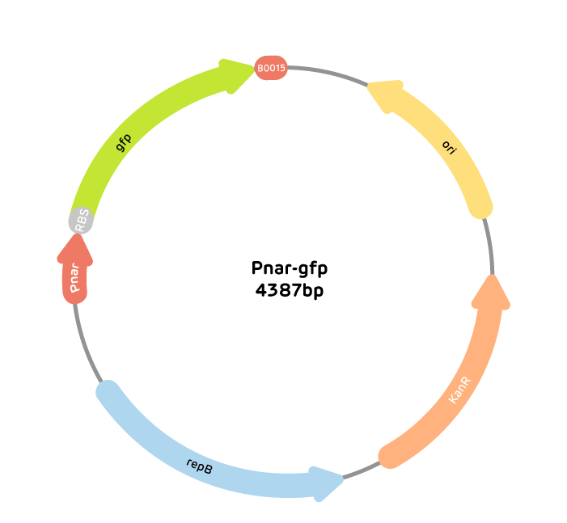

**Fig.2. The expression vector of device P<sub>nar</sub>-GFP**

2.1.2.2 Construction and screening of recombinant engineered bacteria

Using <i>Bacillus subtilis</i> WB800N as the expression host, the secretion expression vector pWB980-DB was transformed by electro-transformation. Inoculate them on LB solid medium coated with 10 μg/mL kanamycin, and incubate them overnight at 37°C. Send transformants to biotechnology company for sequencing.

2.1.2.3 Characterization experiment

Take 2 bottles of 50ml LB liquid medium with 10 μg/mL kanamycin, and inoculate the same amount of recombinant engineered bacteria.

①Culture engineered bacteria which have been transformed successfully for 6 hours.

②Culture the test group and negative control in anaerobic and aerobic environment for 6 hours respectively.

③Use the fluorescence microscope to observe the presence of fluorescence in the test group and the negative control group.

2.1.3 Expected results

Fluorescence can be observed in the test group but not in the negative control group.



**Fig.3. Expected results 1: different expressions of fluorescence between the negative control group and the test group.**

**2.2P<sub>nar</sub>-phy(yCD)**

Our project aims to secrete phytase to immobilize lead ions, so we need to ensure that our system can secrete phytase normally. Our first device has demonstrated the function of oxygen-free inducible promoter P<sub>nar</sub>. So next step, we need to verify whether P<sub>nar</sub> and phytase can achieve a successful assembly.

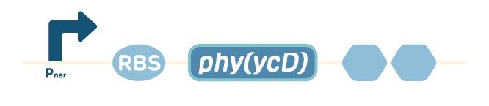

**Fig.4. Device 2.**

2.2.1 Strains and vectors

Strain: <i>Bacillus subtilis</i> WB800N

Plasmid: pWB980-DB

2.2.2 Experimental methods

2.2.2.1 Construction of the expression vector

The pWB980-DB is digested with enzyme EcoRI and PstI. The target fragment of the promoter, RBS, gene of phytase and terminator of this device is synthesized by the biotechnology company with 6×His tags added. Add EcoRI and PstI restriction sites to both ends of the target fragment respectively. Connect the target fragment to the plasmid vector fragment to construct the recombinant expression vector pWB980-DB-P<sub>nar</sub>-phy(ycD).

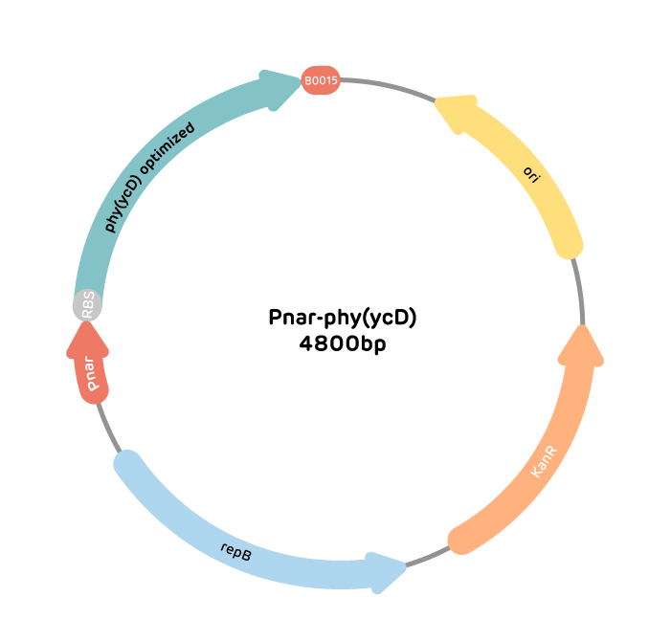

**Fig.5. The expression vector of device 2.**

2.2.2.2 Construction and screening of recombinant engineered bacteria

Using <i>Bacillus subtilis</i> WB800N as the expression host, the secretion expression vector pWB980-DB was transformed by electro-transformation. Inoculate them on LB solid medium coated with 10μg/mL kanamycin, and incubate them overnight at 37°C. Send transformants to biotechnology company for sequencing.

2.2.2.3 Phytase expression and purification

Set up two groups of experiments: (1) the control group: recombinant <i>Bacillus subtilis</i> are cultured in an aerobic condition; (2) the test group: recombinant <i>Bacillus subtilis</i> are cultured in an anaerobic condition.

1. Inoculate recombinant <i>Bacillus subtilis</i> in 20 mL of LB liquid medium containing 10 μg/mL kanamycin, and cultivate them overnight at 37°C with shaking at 180 rpm.

②Inoculate 2% of the overnight cultured bacteria in 100 mL of LB liquid medium containing 10μg/mL kanamycin, and culture them with shaking at 25°C for 24 hours. The supernatant was collected by centrifugation to obtain the crude enzyme solution, and the pure enzyme solution was obtained after Ni-NAT affinity chromatography and Superdex-75 gel chromatography. The purified protein is subjected to SDS-PAGE gel electrophoresis, western blot to determine phytase expression. And gel chromatography is used to obtain the elution profile of the enzyme after gel purification.

③Western Blot：After SDS-PAGE gel electrophoresis, transfer the solution to membrane (wet transfer: 300 mA, 1 h), seal with 5% skimmed milk powder at 4°C overnight, and add TBST (Tris buffered salt-Tween solution, containing 10 mmol/L), pH 7. 6 Tris-HCl, 150 mmol /L NaCl, 0.05% Tween-20) 1:10 000 diluted His primary antibody, incubate at 37°C for 1 h, wash the membrane with TBST 3 times, 15 min each time; Add His secondary antibody diluted 1:20 000 with TBST, incubate at 37°C for 1 h, wash the membrane with TBST 3 times, 15 min each time; HRP-DAB substrate color kit for color development, use Bio-Rad gel imaging system to take pictures.

2.2.2.4 BCA protein concentration verification

（1）Experimental reagents:

①BCA reagent: Take 50 parts of BCA reagent A and 1 part of reagent B and mix well.

②Standard protein solution: Weigh 0.5g bovine serum albumin, dissolve it in distilled water and dilute to 100mL to make a 5mg/mL solution. Dilute ten times when used.

1. Experimental operation:

Draw a standard curve: Take a 96-well microtiter plate and add reagents in the following table.

|  |  |  |  |  |  |  |  |  |
| --- | --- | --- | --- | --- | --- | --- | --- | --- |
| Tube number | 1 | 2 | 3 | 4 | 5 | 6 | 7 | 8 |
| Standard protein solution（μl） | 0 | 1 | 2 | 4 | 8 | 12 | 16 | 20 |
| Distilled water（μl） | 20 | 19 | 18 | 16 | 12 | 8 | 4 | 0 |
| BCA reagent（μl） | 200 | 200 | 200 | 200 | 200 | 200 | 200 | 200 |
| Protein concentration（mg/μl） | 0 | 0.025 | 0.05 | 0.1 | 0.2 | 0.3 | 0.4 | 0.5 |

**Table.1. Draw a standard curve.**

After the above reagents are added, accurately pipet 20μl of sample solution and add 200μl of BCA reagent to the sample, gently shake, then add the above system to the microplate well, keep it at 37°C for 30-60min, cool to room temperature, take the blank as a control, and place it on the microplate reader at 562nm. For colorimetry, draw a standard curve with the content of bovine serum albumin as the abscissa and absorbance as the ordinate. Take the blank of the standard curve as the control, find out the protein content of the sample from the standard curve according to the absorbance value of the sample, and do three sets of replicates for each sample.

2.2.2.5 Verification of the effect of phytase on phosphate hydrolysis

①Preliminary identification of engineered bacteria expressing phytase

Pick a single colony of the transformant and inoculate it on a LB solid medium containing calcium phytate, and then observe the hydrolysis circle after culturing in a 37 ℃ incubator for 36 h.

②Preparation of phosphorus standard curve

Configure 50 mmol standard KH<sub>2</sub>PO<sub>4</sub> solution (weigh 0.6804 g KH<sub>2</sub>PO<sub>4</sub> and dilute it to 100 mL with pH5.5 acetate buffer), and then dilute it to 0.025, 0.05, 0.10, 0.15, 0.20, 0.25, 0.30, 0.35, 0.40 mmol/mL nine concentration gradients with deionized water. Take 1 mL of gradient solution and add 1 mL of 5.0mmol/L sodium phytate solution, then add 2 mL of stop solution, measure absorbance at 415 nm, do 3 sets of repeated experiments for each concentration gradient, and average within the standard deviation range. Draw a standard curve with the concentration of inorganic phosphorus as the abscissa and the absorbance value as the ordinate.

③Determination of phytase activity

Add 0.8 mL of sodium phytate to 0.2 mL of diluted enzyme solution. After reacting for 15 min at pH 6.5 and temperature of 37 ℃, add 1 mL of 5% TCA (trichloroacetic acid) to stop enzyme activity reaction, and then add 1 mL of ferrous sulfate-ammonium molybdate coloring solution, determine the content of inorganic phosphorus in visible light at 415 nm, and calculate the specific activity. (Enzyme activity unit definition: Under the conditions of 37°C and pH 6.5, the amount of enzyme that releases 1 μmol of inorganic phosphorus from a 5.0 mmol/L sodium phytate solution per minute is defined as 1 enzyme activity unit (U).)

2.2.2.6 Verification of the effect of phytase to dissolve phosphorus and solid lead

①Experimental reagents: sodium phytase solution 1.5 mM, phytase solution, 230mg/L PbCl<sub>2</sub> solution

②test group:

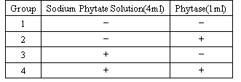



**Table.2. Set test groups for determination of phytase activity.**

③Experimental steps: Set up four groups of experiments, with whether to add sodium phytase solution and whether to add phytase solution as variables. When phytase solution or sodium phytase solution is not added, the same amount of ddH<sub>2</sub>O is used instead. In each group of experiments, 15ml of 230mg/L PbCl<sub>2</sub> is added to react for 1h, and then the lead content in the reaction system is determined by dithizone colorimetry. The specific operation steps are as follows:

Firstlyt, prepare a lead standard series with lead content of 0, 0.5, 1.0, 2.0, 4.0, 6.0, 8.0μg, and measure it in the range of 540nm and pH 8.5-11, and draw a standard curve based on the data.

Secondly, take 10ml of the reaction solution in a 100ml separatory funnel, add 2ml 20% ammonium citrate, 1ml 20% hydroxylamine hydrochloride, 2d phenol red indicator, adjust the pH to 8.5-9.0 with concentrated ammonia and add 1ml 10% potassium hydride and shake. Add 10ml of dithizone chloroform application solution, shake and layer, put the chloroform layer into a clean 10ml colorimetric tube, measure the spectrophotometry at 540nm, and find out the corresponding content from the standard curve.

2.2.3 Expected experimental results

2.2.3.1 PCR amplification phy (ycD) and construction of secretion vector

After identification, the recombinant expression plasmid pWB980-phy (ycD) and successfully transformed engineered bacteria were obtained.

2.2.3.2 Phytase expression and purification

The control group has no production of phytase, and the test group has production of phytase.

The molecular weight that can be determined by SDS-PAGE analysis of the expressed enzyme is 45 KD, and the protein can be determined as phytase by Western blot.

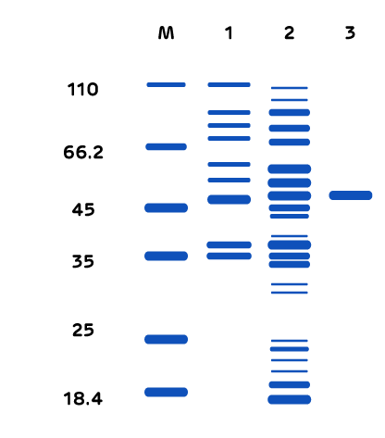

**Fig.6. Expected results 2: SDS-PAGE image of predicted expression product.**

2.2.3.3 Verification of BCA protein concentration

The secreted protein concentration is obtained through this experimental program.

2.2.3.4 Verification of the effect of phytase on phosphorus hydrolysis

①Preliminary screening of strains

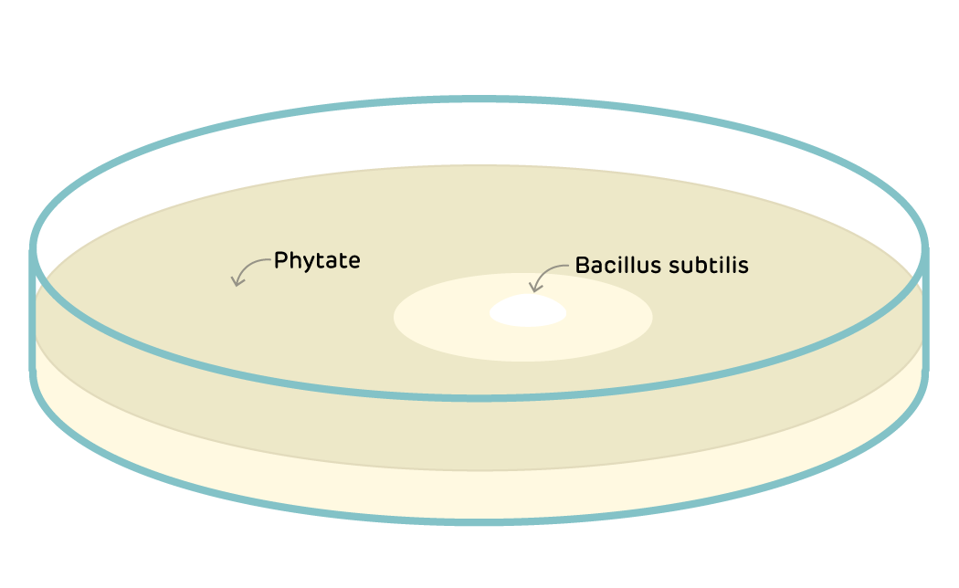

**Fig.7. Expected results 3: the transparent** **hydrolysis circle produced by engineered bacteria.**

②Phytase activity determination

According to the experiment, the relative activity of phytase can be obtained.

According to literature prediction, the relative activity of phytase is about 40%.

2.2.3.5 Verification of the effect of phytase on phosphorus hydrolysis and lead fixation

Only in the group 4, whose reaction system has both phytase and sodium phytate, the lead content is reduced.

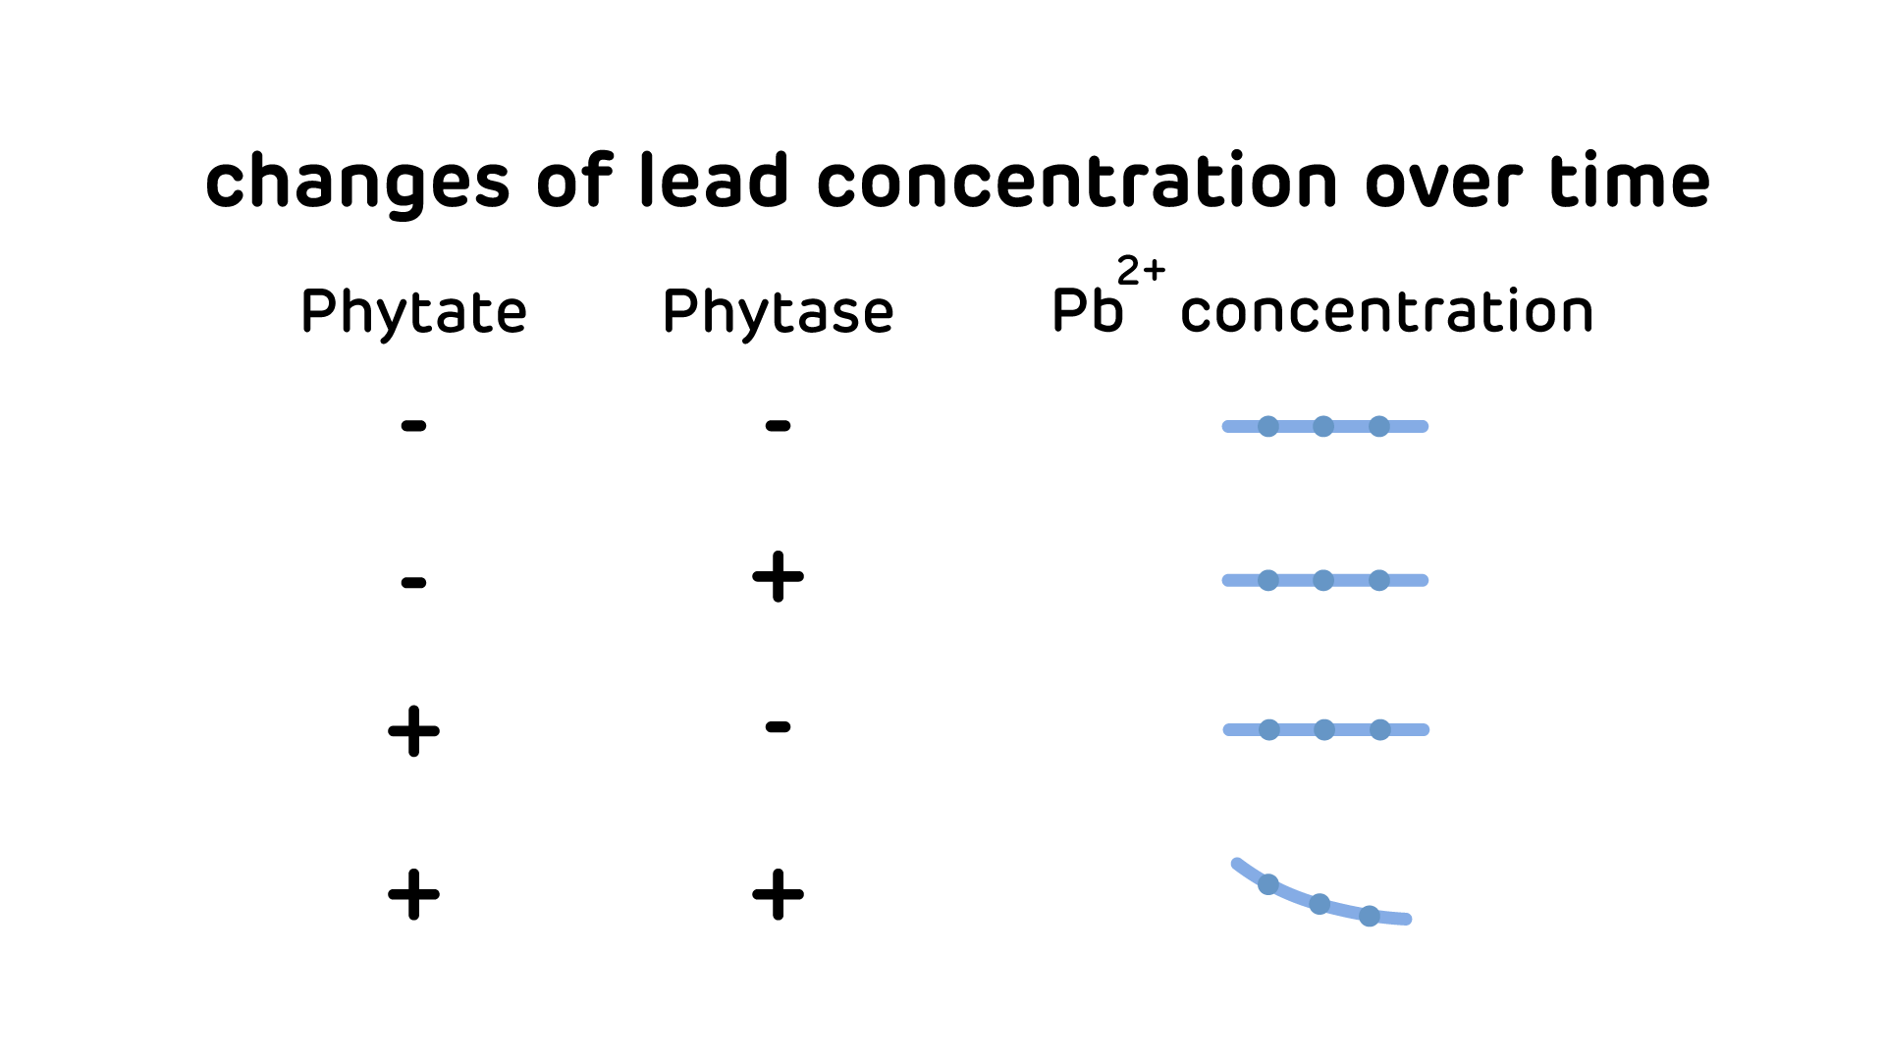

**Fig.8. Expected results 4: changes of lead concentration over time.**

**2.3** **P**<sub>nar</sub>**-CⅠ-P**<sub>CⅠ</sub>**-GFP**

On the basis of successful verification of device2.1, we can verify the CⅠ repressor and the promoter P<sub>CⅠ</sub>, which connects P<sub>nar</sub> and the following toehold switch（in Device 2.4）. Successful verification of this composite part can well consolidate our more complicated devices below.

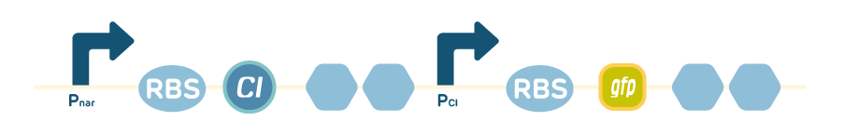

**Fig.9. device 3**

2.3.1 Strains and vectors

Strain: <i>Bacillus subtilis</i> WB800N

Plasmid: pWB980-DB

2.3.2 Experimental methods

2.3.2.1Construction of the expression vector

Similar to procedure 2.1.2.1, construct the expression vector P<sub>nar</sub>-CⅠ-P<sub>CⅠ</sub>-GFP.

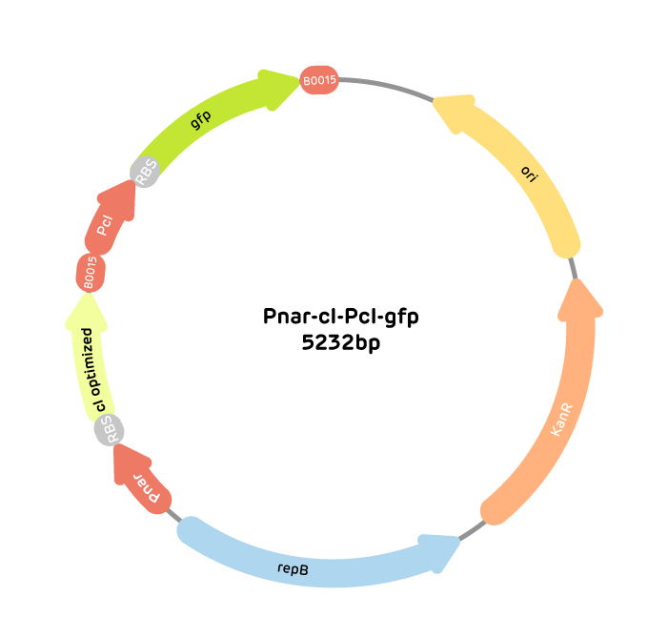

**Fig.10. The vector of device 3.**

2.3.2.2 Construction and screening of recombinant engineered bacteria

Similar to 2.1.2.2。

2.3.2.3Medium experiment

Take 2 bottles of 50ml LB liquid medium with 10μg/mL kanamycin, and inoculate the same amount of recombinant engineered bacteria.

①Culture engineered bacteria which have been transformed successfully for 6 hours, the test group is cultured in an anaerobic environment, and the negative control group is cultured in an aerobic environment.

②Use the microplate reader to observe the presence of fluorescence in the test group and the control group at 0 min, 10 min, 20 min, 30 min, 40 min, 60 min, 80 min, and 120 min.

2.3.3 Expected experimental results

The test group: the fluorescence intensity gradually decreases

The control group: the fluorescence intensity remains unchanged

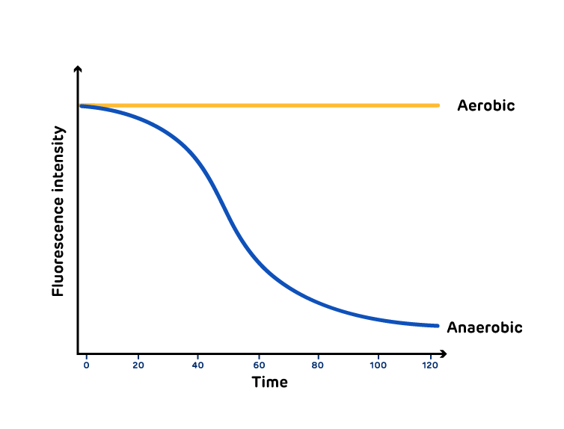

**Fig.11.Expected results 5: changes of fluorescence intensity under an anaerobic induced environment over time.**

**2.4****P**<sub>**liaG**</sub>**- trigger RNA-P**<sub>**CⅠ**</sub>**-switch RNA-GFP**

Toehold switch comprising of trigger RNA and switch RNA is significant to our overall design of genetic circuit. So, it’s essential to verify the feasibility of it. We add the gfp gene in the downstream of the switch sequence and use a constitutive promoter P<sub>liaG</sub> to control expression of trigger RNA.

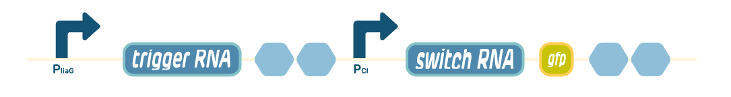

**Fig.12. device 4**

2.6.1 Strains and vectors

Strain: <i>B.subtilis</i> WB800N

Plasmid: pWB980-DB

2.6.2 Experimental methods

2.6.2.1 Construction of the expression vector

Similar to procedure 2.1.2.1, construct the expression vector P<sub>liaG</sub>- trigger RNA-P<sub>CⅠ</sub>-switch RNA-GFP.

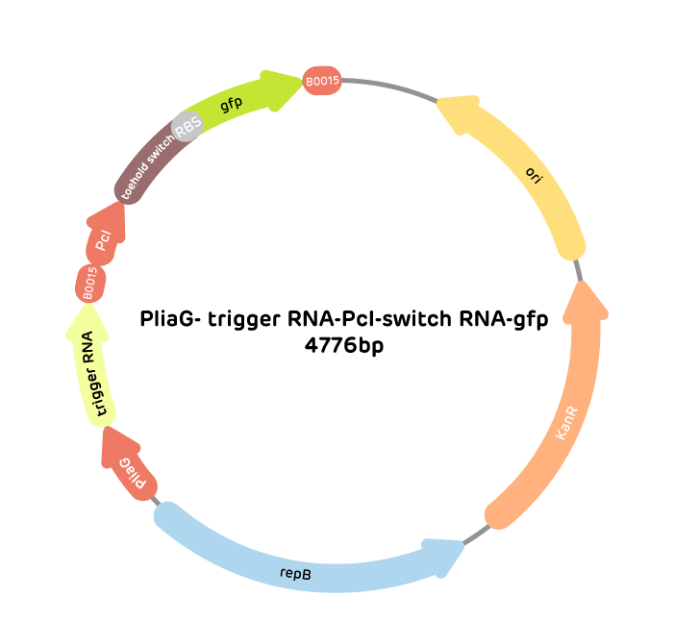

**Fig.13. The expression vector of device 4.**

2.6.2.2 Construction and screening of recombinant engineered bacteria

Similar to 2.1.2.2。

2.6.2.3 Characterization experiment

Take 2 bottles of 50ml LB liquid medium with 10μg/mL kanamycin, the one used for the test group is added 10μg/mL kanamycin and the other used for the control group is not. Test group which successfully transformed engineered bacteria, and control group which transformed pWB980-DB, are inoculated the same amount in medium.

After culturing them for a period of time, use the fluorescence microscope to observe the presence of fluorescence in the test group and the control group.

2.6.3 Expected results

Fluorescence can be observed in the test group but not in the negative control group.

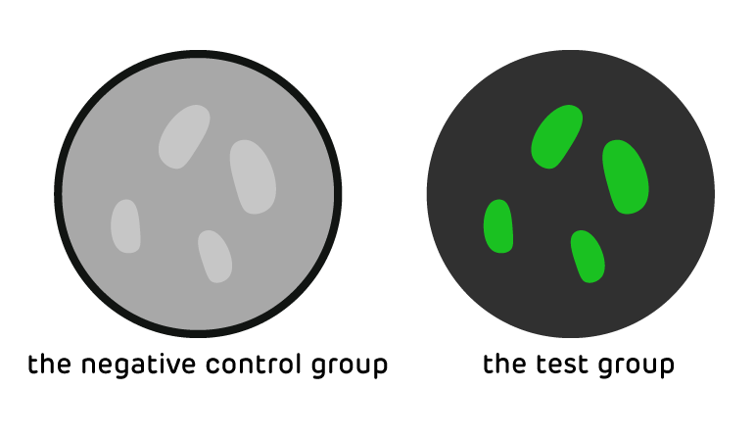**Fig.14.Eexpected results 6: different expressions of fluorescence between the control group and the test group.**

**2.5** **P**<sub>**nar**</sub>**-trigger RNA-P**<sub>**CⅠ**</sub>**-switch RNA-mazF**

Now we have verified effectiveness of P<sub>nar</sub>, CⅠ repressor and toehold switch. So, further verification of more complicated assembly based on above parts can lay the foundation of our future demonstration of the whole system. Considering the bio-safety, we will let our engineered bacteria commit suicide by expressing toxin protein MazF. Based on this, we tried to achieve a good assembly of the parts P<sub>nar</sub>, P<sub>CⅠ</sub>, toehold switch and MazF.

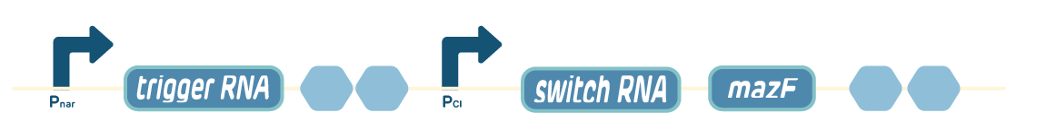

**Fig.15. Device 5.**

2.5.1Strains and vectors

Strain:<i>B.subtilis</i> WB800N

Plasmid: pWB980-DB

2.5.2Experimental methods

2.5.2.1 Construction of the expression vector

Similar to procedure 2.1.2.1, construct the expression vector P<sub>nar</sub>-trigger RNA-P<sub>CⅠ</sub>-switch RNA-mazF.

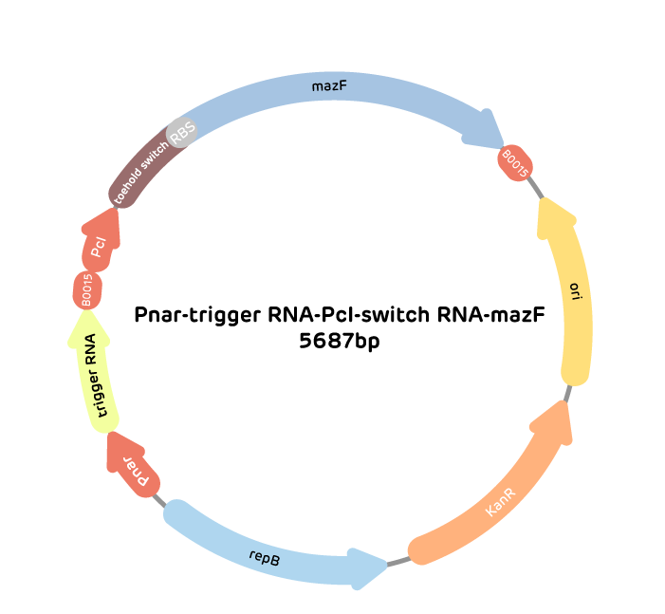

**Fig.16. The expression vector of device 5.**

2.5.2.2 Construction and screening of recombinant engineered bacteria

Similar to 2.1.2.2。

2.5.2.3 Characterization experiment

①Take 2 bottles of 50ml LB liquid medium with 10μg/mL kanamycin, and inoculate the same amount of recombinant engineered bacteria.

②After culturing engineered bacteria which have been transformed successfully for 6 hours, the test group is cultured in an anaerobic induced environment for 6 hours, and the negative control group is cultured in an aerobic environment for 6 hours.

③Measure OD<sub>600</sub> of bacteria liquid every 2 hours.

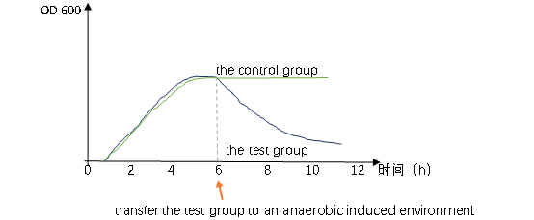

**Fig.17. Expected results 7: changes of OD**<sub>600</sub> **over time.**

**2.6** **P**<sub>**liaG**</sub>**-lacⅠ-P**<sub>**grac**</sub>**-CⅠ-P**<sub>**CⅠ**</sub>**-GFP**

In the laboratory, to guarantee successful culture of our engineered <i>Bacillus subtilis</i>, we need to introduce an IPTG induction system to our bacteria, so this composite part is to demonstrate the IPTG induction system which can actually work in engineered bacteria.



**Fig.18. Device 6.**

2.6.1Strains and vectors

Strain:<i>B.subtilis</i>WB800N

Plasmid: pWB980-DB

2.6.2 Experimental methods

2.6.2.1 Construction of the expression vector

Similar to procedure 2.1.2.1, construct the expression vector P<sub>liaG</sub>-lacⅠ-P<sub>grac</sub>-CⅠ-P<sub>CⅠ</sub>-GFP.

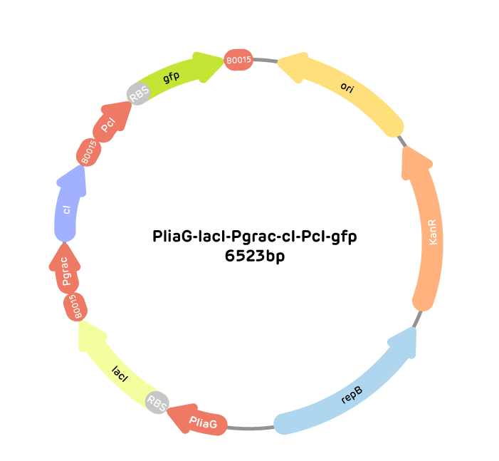

**Fig.19. The expression vector of device 6.**

2.6.2.2 Construction and screening of recombinant engineered bacteria

Similar to 2.1.2.2.

2.6.2.3 Characterization experiment

Take 2 bottles of 50mL LB liquid medium with 10μg/mL kanamycin, and inoculate the same amount of recombinant engineered bacteria.

1. After culturing for 3 hours, the test group is cultured with 1 mM IPTG at 37°C and 200 rpm for 2 hours while the IPTG is not added to control group.

②Use the fluorescence microscope to observe the presence of fluorescence in the test group and the control group.

2.6.3 Expected results

Fluorescence can be observed in the negative control group but the test group cannot.



**Fig.20. Expected results 8: different expressions of fluorescence between the control group and the test group.**

The engineering of biology has been the core of our project, so we want to make sure that our devices are as successful as possible. We designed the above experiments to verify the engineering success of our devices, but these tests were based on literature or mathematical model predictions. There will be errors or failures in the actual experimental verification inevitably. For example, mis-operation during experiments and objective factors, such as kit problems, may cause unexpected results. Therefore, it is necessary to conduct fault detection for unexpected results. The inspection thinking pattern of each device is roughly the same, so in order to conduct fault troubleshooting quickly and systematically, we made an "experiment failure troubleshooting handbook", which summarized the possible causes of experiment failure and proposed corresponding solutions.

We use the troubleshooting handbook to help us systematically identify the causes of failure and ensure the success of our devices to the greatest extent. At the same time, we hope that our handbook can help other devices to be troubleshooted.

**三、System**

After verifying and evaluating above six devices by designing experiments to achieve engineering success, we verified and evaluated the overall circuit by simulating three different stages of engineered bacteria: in the laboratory, in the intestine and in the excrement. As shown in the table below, the first stage is culturing with IPTG in the aerobic environment; the second stage is culturing without IPTG in the anaerobic environment and the third stage is culturing without IPTG in the aerobic environment.

|  |  |  |
| --- | --- | --- |
| Experiment | O<i>2</i> | IPTG |
| 1 | + | + |
| 2 | - | - |
| 3 | + | - |

**Table.3. Simulating three different stages of engineered bacteria.**

For the above experiments, our expected results are as follows:

1.In the laboratory: no expression of phytase, engineered bacteria do not commit suicide.

2.In the intestine: expression of phytase, engineered bacteria do not commit suicide.

3.In the excrement: no expression of phytase, engineered bacteria commit suicide.

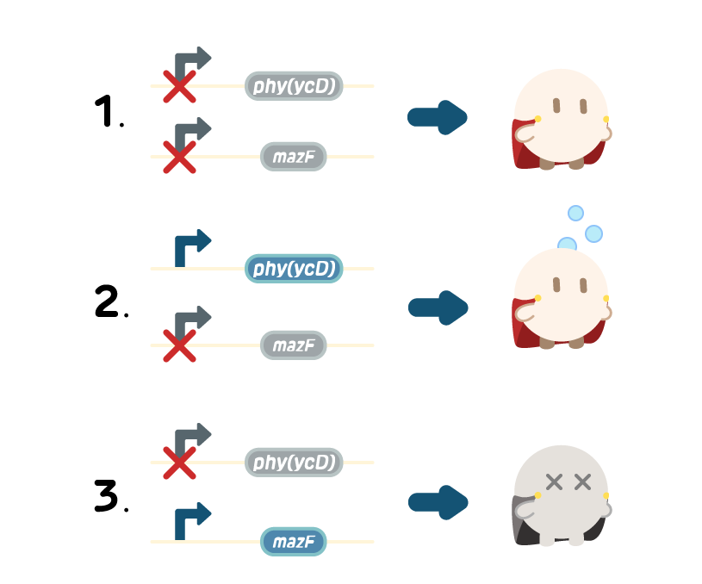

**Fig.21. Simulated expressions of engineered bacteria in three different stages.**

In our project, phytase and kill switch, which are core parts, play important roles and may cause bad results if they are non-functional. We assumed unexpected results caused by them, speculated possible reasons and proposed treatments respectively.

So how can we find out possible reasons? Generally, we can only observe phenomena of experiments, such as fluorescence and hydrolysis circle. However, we know that every phenomenon is caused by corresponding proteins. For example, only if green fluorescence proteins are expressed, can we detect green fluorescence. In this perspective, we can speculate possible reasons according to the common process of producing protein: transcription of the relevant gene, translation of mRNA, proper protein folding and configuration, secretion from cells (if necessary) and enzyme activity.

1. PHYTASE(ycD)

|  |  |  |  |
| --- | --- | --- | --- |
| Unexpected results | | Possible reasons | Treatment |
| Pyromorphite cannot be formed | unable to detect | Noneffective experimental methods | Apply more sensitive and advanced methods like XRD analysis |
| low activity of phytase | Oxygen switch is non-functional | 1. Search for enzymes that canfunction better. 2. Change characteristics of phytase. |
| Proteins don't fold properly |
| Proteins can’t be secreted |
| Inclusion Body formation |
| Enzymatic reaction conditions are not suitable |

**Table.4. Analysis of phytase.**

2.TOEHOLD-BASED KILL SWITCH

Kill switch problems can be divided into two situations: mis-killing and non-killing, possibly reasons are shown below.

|  |  |  |  |  |
| --- | --- | --- | --- | --- |
| Unexpected results | | Possible reasons | | Treatment |
| Suicide  mistake | Mis-killing: Toehold mistakenly opens, toxin protein expresses.  (phases I and II) | In the laboratory | Pgrac is not successfully induced or Pgrac is not strong enough | 1.Search for more sensitive and effective parts, such as much stronger oxygen-free inducible promoters and other switches that can be used as an “AND” gate.  2. Use more precise experimental methods, such as flow cytometry. |
| In the intestine of earthworms | P<sub>nar</sub> is not strong enough |
| Common reasons | Toehold switch background expression |
| The activity of CI repressor is low |
| Toehold switch cannot form stem-ring structure |
| CI cannot be expressed |
| Expression of CI repressor don’t reach functional threshold |
| Non-killing: toxin protein isn’t expressed.  (phase III) | Toxin protein | Fold improperly |
| Inclusion Body formation |
| Degradation |
| Toehold does not open | The degradation rate of trigger RNA is too high |
| Concentration of switch RNA or trigger RNA dose not reach threshold |
| The degradation rate of CI is too low |

**Table.6. Analysis of the kill switch.**

**四、Future Steps**

Due to the impact of the epidemic COVID-19, we can’t conduct experiments practically. However, we put forward ideas to further optimize the engineering design according to theoretical design and mathematical model.

1.Optimize the experimental plan:

(1) when designing the experiment on the effect of kill switch, we can further detect the number of living bacteria by flow cytometry or dilution spread to avoid the small difference in total biomass caused by incomplete cleavage of dead bacteria.

(2) adopt more advanced detection methods such as XRD analysis to detect pyromorphite.

2. Add the colonization part:

For the purpose of engineering, we hope that the engineered bacteria can colonize in the intestine of earthworm for a long time, expressing phytase to hydrolyze phytate in soil and forming pyromorphite with lead ions.

3. Further soil experiments will be carried out:

On the basis of laboratory experiments, the effect of engineered bacteria under real soil conditions would be further verified. At the same time, earthworm experiments can also be carried out under approval of the laboratory and safety policies.

4. Find and choose more effective parts:

(1) change the enzymatic characteristics of phytase or find a more suitable enzyme.

(2) use more sensitive oxygen-free inducible promoter.

(3) use switches that have lower basic expression and broader adjusting range as an “AND” gate to replace toehold switch.

[1] Xi Wang, Wenliang Lu, Mingze Yao, et al. Heterologous expression and purification of Bacillus phytase phy (ycD) Gene in E.coli[J]. Chinese Journal of Applied and Environmental Biology, 2014, 20(02):295-299.

[2] Green Alexander A, Silver Pamela A, Collins James J, Yin Peng. Toehold switches: de-novo-designed regulators of gene expression[J]. Cell,2014,159(4):1-15.

[3] Kerovuo J, Rouvinen J, Hatzack F. Analysis of myo-inositol hexakisphosphate hydrolysis by Bacillus phytase: indication of a novel reaction mechanism[J]. Biochemical journal,2000,352Pt 3(Pt 3):623-628.

[4] Yamaguchi Y, Inouye M. Regulation of growth and death in Escherichia coli by toxin-antitoxin systems[J]. Nature Reviews Microbiology, 2011, 9 (11) :779-790.

[5]Tavares Batista M, Souza RD, Paccez JD, Luiz WB, Ferreira EL, Cavalcante RC, Ferreira RC, Ferreira LC. Gut adhesive Bacillus subtilis spores as a platform for mucosal delivery of antigens. Infect Immun. 2014;82(4):1414–1423.